***Dt : 21/11/2022***

***\*imp***

***Thread Synchronization:***

***=>The process of odering the threads for execution is known as Thread***

***Synchronization***

***=>Thread synchronization process can be performed in two ways:***

***1.Mutual Exclusion process***

***2.Thread Communication process***

***1.Mutual Exclusion process:***

***=>The process of locking the programming resources and ordering the threads for***

***execution is known as Mutual Exclusion process.***

***(Programming Resources : Class,Object,Method)***

***=>This Mutual Exclusion process can be performed in three ways:***

***(a)synchronized block - Object Locking process***

***(b)synchronized method - Instance method Locking process***

***(c)static synchronization - Class Locking process***

***(a)synchronized block:***

***=>The process of declaring some statements using "synchronized" keyword is***

***known as synchronized block.***

***=>we use synchronized block to lock the objects.***

***syntax:***

***synchronized(object_ref)***

***{***

***//statements***

***}***

***Ex-program :***

***Printer.java***

***package test;***

***public class Printer {***

***public void print(int n,String uname) {***

***for(int i=1;i<=n;i++) {***

***System.out.println("Print out for User : "+uname);***

***try {***

***Thread.sleep(2000);***

***}catch(Exception e) {e.printStackTrace();}***

***}***

***}***

***}***

***UserOne.java***

***package test;***

***public class UserOne implements Runnable{***

***public Printer p=null;***

***public UserOne(Printer p) {***

***this.p=p;***

***}***

***@Override***

***public void run() {***

***synchronized(p)***

***{***

***p.print(5, "RAM");***

***}***

***}***

***}***

***UserTwo.java***

***package test;***

***public class UserTwo implements Runnable{***

***public Printer p=null;***

***public UserTwo(Printer p) {***

***this.p=p;***

***}***

***@Override***

***public void run() {***

***synchronized(p)***

***{***

***p.print(5, "RAJ");***

***}***

***}***

***}***

***DemoThread3.java(MainClass)***

***package maccess;***

***import test.*;***

***public class DemoThread3 {***

***public static void main(String[] args) {***

***Printer p = new Printer();***

***UserOne ob1 = new UserOne(p);***

***UserTwo ob2 = new UserTwo(p);***

***Thread t1 = new Thread(ob1);***

***Thread t2 = new Thread(ob2);***

***t1.start();***

***t2.start();***

***}***

***}***

***o/p:***

***Print out for User : RAM***

***Print out for User : RAM***

***Print out for User : RAM***

***Print out for User : RAM***

***Print out for User : RAM***

***Print out for User : RAJ***

***Print out for User : RAJ***

***Print out for User : RAJ***

***Print out for User : RAJ***

***Print out for User : RAJ***

***Diagram:***

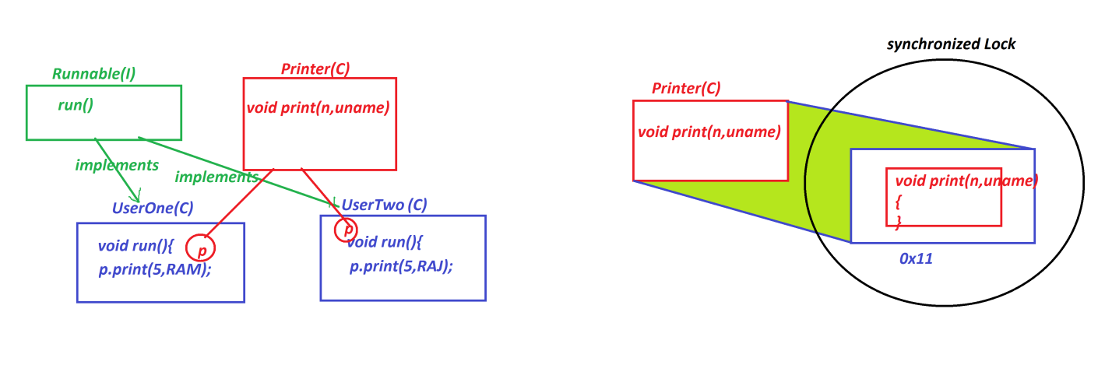

***========================================================================***

***Limitation of Object Locking process:***

***=>In Object Locking process the total instance members available within the***

***Object,will be under the lock.***

***========================================================================***

***(b)synchronized method:***

***=>The process of declaring Instance method with synchronized keyword is known***

***as synchronized method.***

***=>In this process,the Instance method will be under the lock and the method***

***can be used by one user at-a-time***

***syntax:***

***synchronized return_type method_name(para_list)***

***{***

***//method_body***

***}***

***Ex-program:***

***Printer.java***

***package test;***

***public class Printer {***

***public synchronized void print(int n,String uname) {***

***for(int i=1;i<=n;i++) {***

***System.out.println("Print out for User : "+uname);***

***try {***

***Thread.sleep(2000);***

***}catch(Exception e) {e.printStackTrace();}***

***}***

***}***

***}***

***UserOne.java***

***package test;***

***public class UserOne implements Runnable{***

***public Printer p=null;***

***public UserOne(Printer p) {***

***this.p=p;***

***}***

***@Override***

***public void run() {***

***p.print(5, "RAM");***

***}***

***}***

***UserTwo.java***

***package test;***

***public class UserTwo implements Runnable{***

***public Printer p=null;***

***public UserTwo(Printer p) {***

***this.p=p;***

***}***

***@Override***

***public void run() {***

***p.print(5, "RAJ");***

***}***

***}***

***DemoThread3.java(MainClass)***

***package maccess;***

***import test.*;***

***public class DemoThread4 {***

***public static void main(String[] args) {***

***Printer p = new Printer();***

***UserOne ob1 = new UserOne(p);***

***UserTwo ob2 = new UserTwo(p);***

***Thread t1 = new Thread(ob1);***

***Thread t2 = new Thread(ob2);***

***t1.start();***

***t2.start();***

***}***

***}***

***o/p:***

***Print out for User : RAM***

***Print out for User : RAM***

***Print out for User : RAM***

***Print out for User : RAM***

***Print out for User : RAM***

***Print out for User : RAJ***

***Print out for User : RAJ***

***Print out for User : RAJ***

***Print out for User : RAJ***

***Print out for User : RAJ***

***========================================================================***

***(c)static synchronization:***

***=>The process of declaring static method with "synchronized" keyword is***

***known as static synchronization.***

***syntax:***

***synchronized static return_type method_name(para_list)***

***{***

***//method_body***

***}***

***=>In static synchronization process the lock is applied on class and all static***

***members of class will be synchronized.(Class Locking process)***

***Ex:***

***Printer.java***

***package test;***

***public class Printer {***

***public synchronized static void print(int n,String uname) {***

***for(int i=1;i<=n;i++) {***

***System.out.println("Print out for User : "+uname);***

***try {***

***Thread.sleep(2000);***

***}catch(Exception e) {e.printStackTrace();}***

***}***

***}***

***}***

***UserOne.java***

***package test;***

***public class UserOne implements Runnable{***

***@Override***

***public void run() {***

***Printer.print(5, "RAM");***

***}***

***}***

***UserTwo.java***

***package test;***

***public class UserTwo implements Runnable{***

***@Override***

***public void run() {***

***Printer.print(5, "RAJ");***

***}***

***}***

***DemoThread3.java(MainClass)***

***package maccess;***

***import test.*;***

***public class DemoThread5 {***

***public static void main(String[] args) {***

***UserOne ob1 = new UserOne();***

***UserTwo ob2 = new UserTwo();***

***Thread t1 = new Thread(ob1);***

***Thread t2 = new Thread(ob2);***

***t1.start();***

***t2.start();***

***}***

***}***

***o/p:***

***Print out for User : RAM***

***Print out for User : RAM***

***Print out for User : RAM***

***Print out for User : RAM***

***Print out for User : RAM***

***Print out for User : RAJ***

***Print out for User : RAJ***

***Print out for User : RAJ***

***Print out for User : RAJ***

***Print out for User : RAJ***

***====================================================================***

***\*imp***

***2.Thread Communication process:***

***=>The process of establishing Communication b/w threads using the following***

***methods from java.lang.Object class is known as "Thread Communication process".***

***(a)wait()***

***(b)notify()***

***(c)notifyAll()***

***(a)wait():***

***=>wait() method is used to stop the thread execution temporarly until it***

***receives msg in the form of notify() or notifyAll()***

***Method Signature:***

***public final void wait() throws java.lang.InterruptedException;***

***(b)notify():***

***=>notify() method will execute the locked resource completedly and unlock the***

***resource,and send the msg to the next waiting thread.***

***Method Signature:***

***public final native void notify();***

***(c)notifyAll():***

***=>notifyAll() method will execute the locked resource completedly and unlock the***

***resource,and send the msg to the next waiting multiple threads.***

***Method Signature:***

***public final native void notifyAll();***

***Ex:(Program to demonstrate Producer-Consumer problem)***

